Design and Implementation of Memristor-Based Filters, Logic Gates, and SRAM for Advanced Circuit Applications

NAREDLA NAGANNA DORA SASTRY

S20220020298

**Abstract**

This research investigates the applications of memristors in circuit design, focusing on their use in low-pass and high-pass filters, digital logic gates, and memory operations. The circuits are designed and simulated in LT Spice, leveraging the memristor's unique resistance-switching properties. The study also examines read and write operations using pulse signals, showcasing memristors' potential in compact, energy-efficient systems. Results validate the functionality and versatility of memristor-based circuits.

**1. Introduction**

Memristors, as the fourth fundamental circuit element, possess unique properties that enable compact designs for both analog and digital circuits. This paper explores their applications in filters, logic gates, and memory operations, with a focus on simulation-based analysis using LTSpice. Special attention is given to the use of pulse signals for performing reliable read and write operations.

**2. Methodology**

**2.1 Simulation Setup**

1. **Memristor Model:**
   * I used or created a simple memristor model in LT spice.
2. **Circuit Configuration:**
   * I connected the memristor in the SRAM design and set the necessary voltages for writing and reading.

**2.2 Circuit Design**

**2.2.1 Code for Memristor Setup:**

**Operation:**

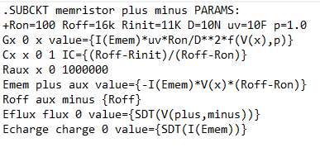

**Memristor Circuit:**

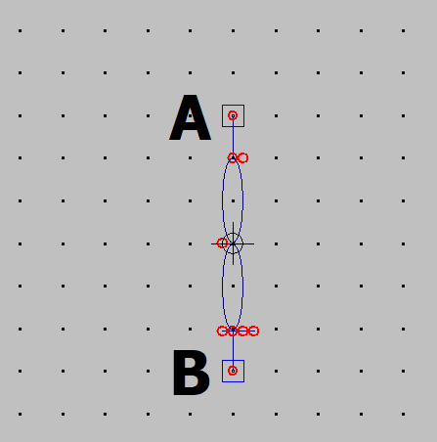

2.2.2 SRAM Circuit Design

Write Operation:

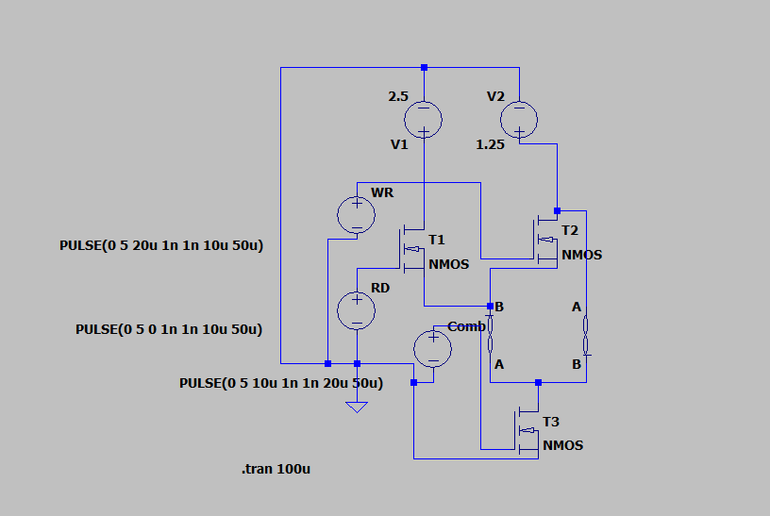

Working :

* This is a circuit connected the memristors parallel for write operation. Here I used MOSFET, Voltage source in this operation.
* The voltage sources are **READ, WRITE, COMB** signals to perform the write operation.
* The write operation is triggered by enabling the write signal. This typically involves setting a control signal (like WE for **Write Enable**) to high.
* When the Write is 1 High (vdd), then the Read is 0 low and the Comb signal will manage the voltage to make active operation and the write is 0 low when the read is 1 high.
* They are the graphs in voltage for the above signals, comparing with the Research Paper.

**GRAPHS in Paper:**

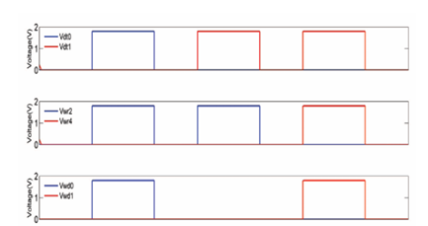

Write Operation in Blue Read Operation in Red

**Graphs in LT Spice:**

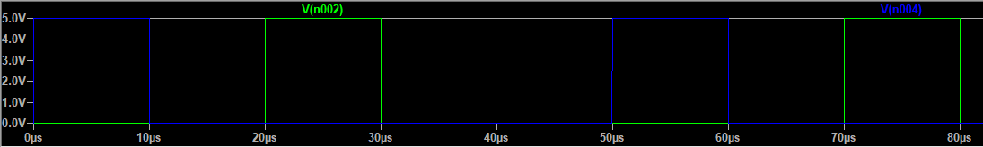

Write In Green Read in Blue

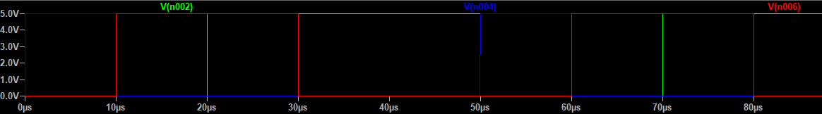

Comb Signal is RED

Read Operation:

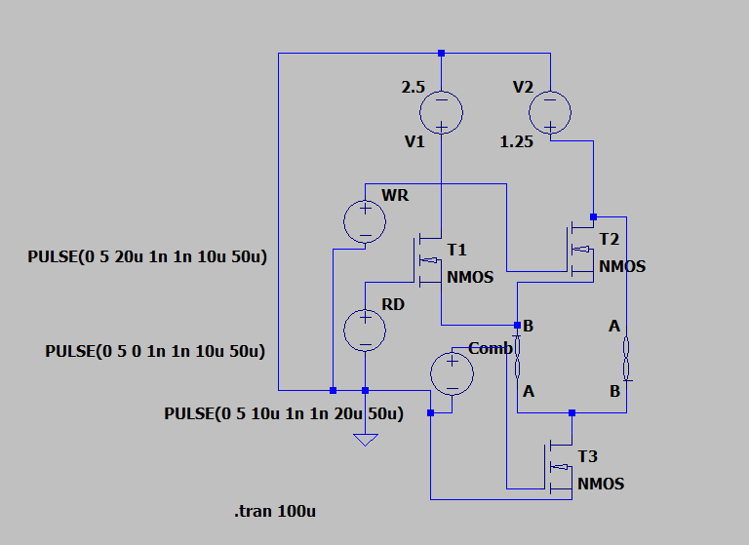

Working :

1. This circuit connects memristors in parallel for the read operation, utilizing MOSFETs and voltage sources to control the operation.
2. Voltage sources provide **READ, WRITE,** and **COMB** signals.
3. The read operation is activated by enabling the **READ** signal, which requires setting the **READ** control signal to high.
4. During the read operation, when **READ** is high (Vdd), the **WRITE** signal is low, and the **COMB** signal manages the appropriate voltage levels to ensure accurate read functionality
5. The **READ** and **WRITE** signals toggle, ensuring that one is low when the other is high.
6. The resulting voltage graphs for **READ, WRITE,** and **COMB** signals can be analyzed to verify performance, as compared to theoretical values in related research papers.

**GRAPHS in Paper:**

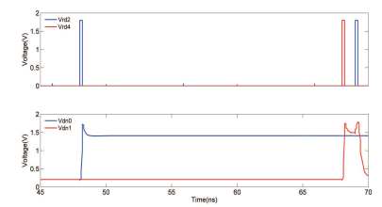

**Graphs in LT Spice:**

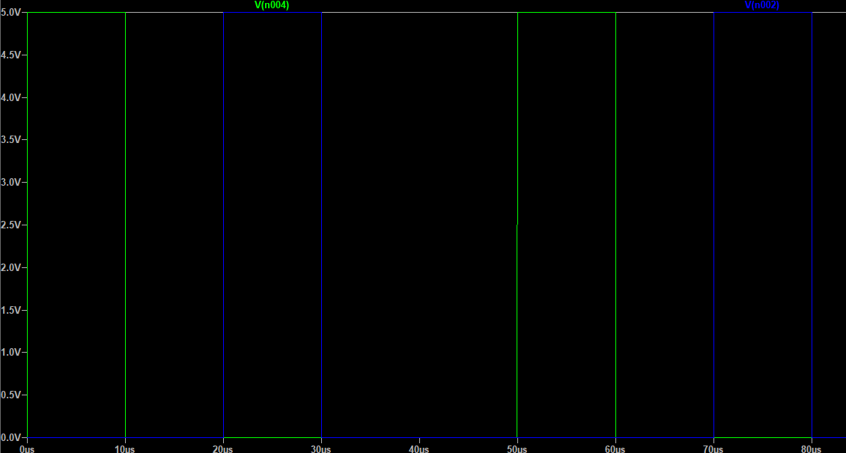

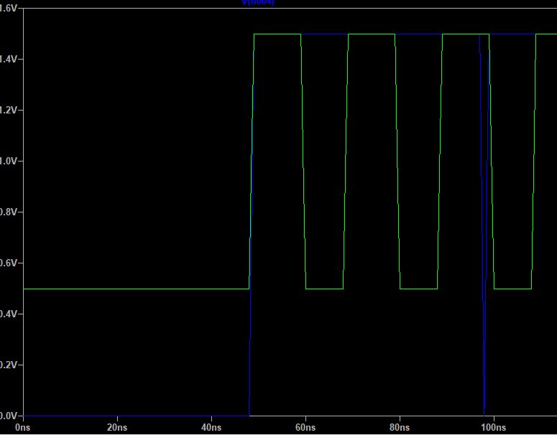

**3 Novelties**

**3.1 Filters**

**1. Low Pass**

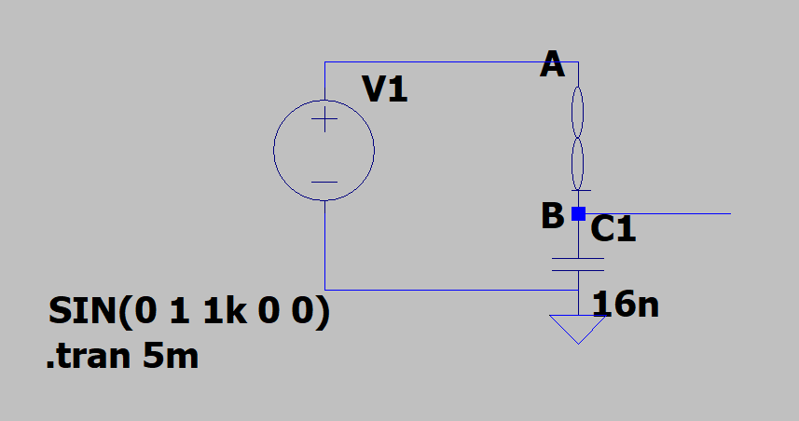 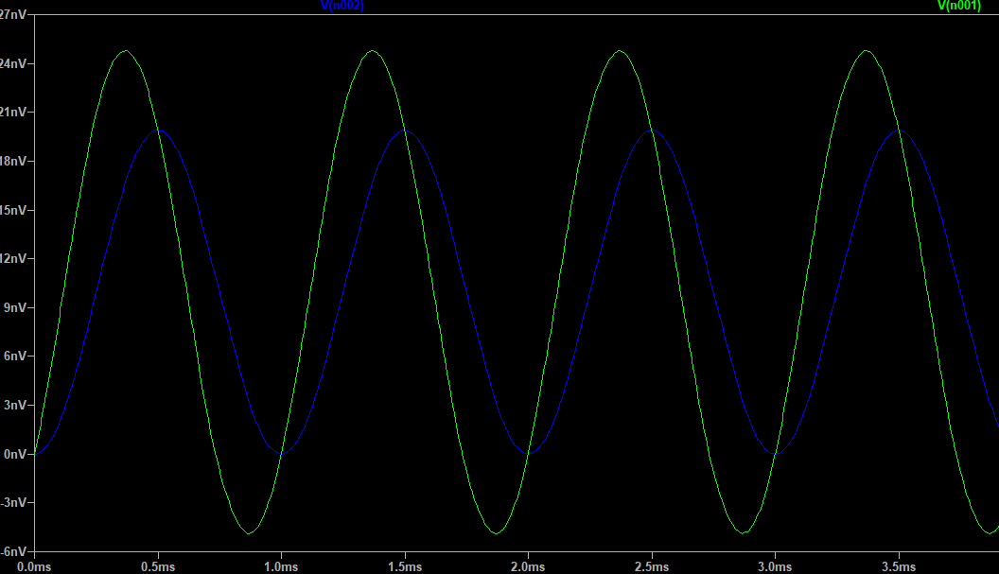

**2 High Pass**

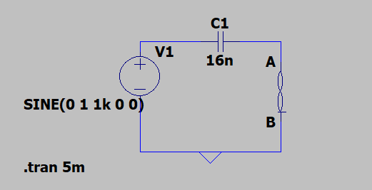 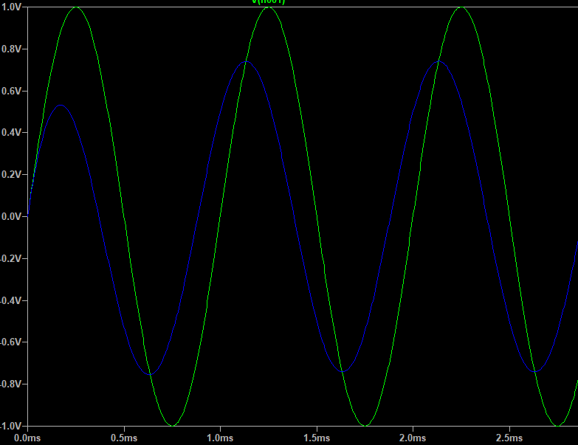

**3 Band Pass**

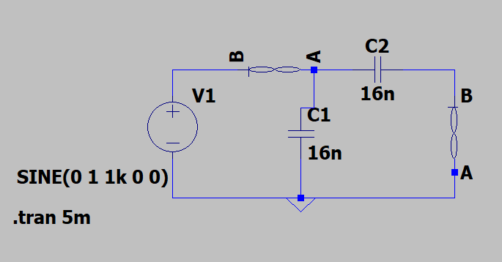

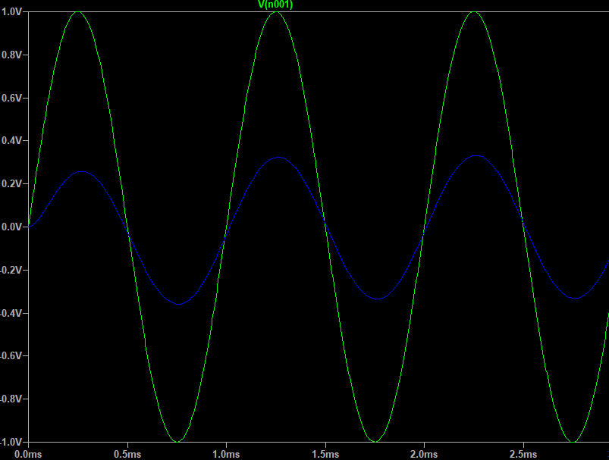

**4 Band Stop**

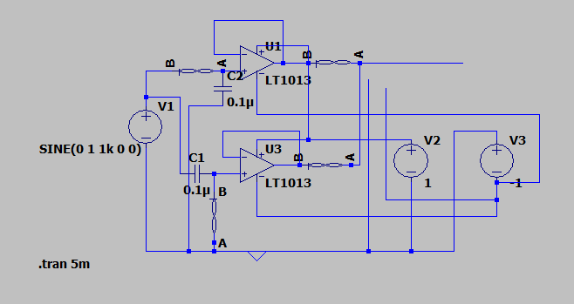

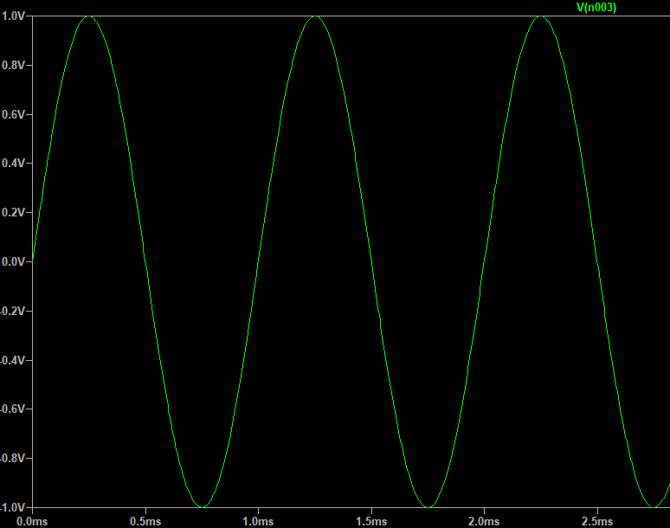 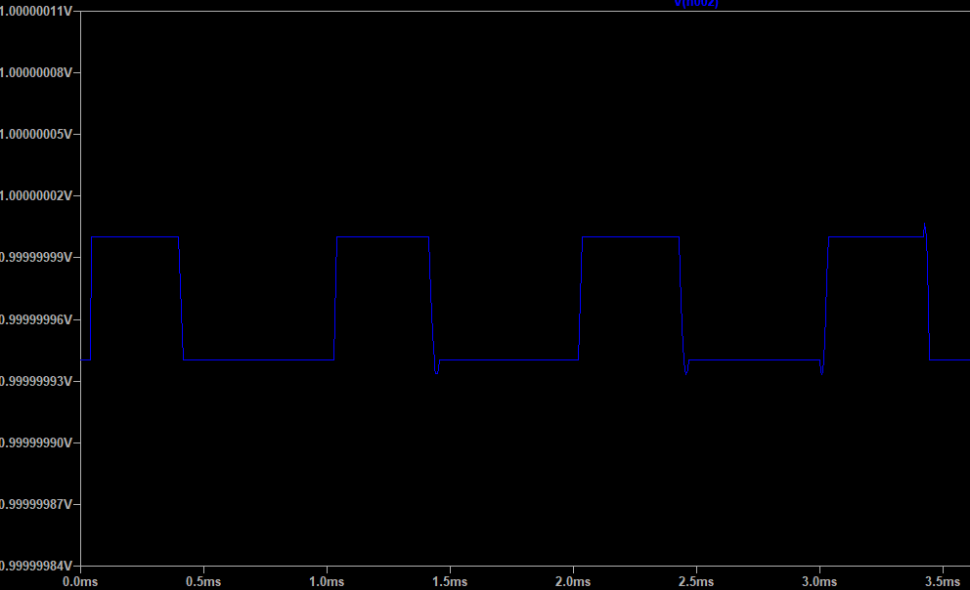

**Input output**

3.2 Logic Gates

AND OR

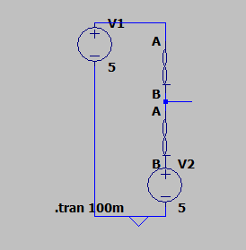 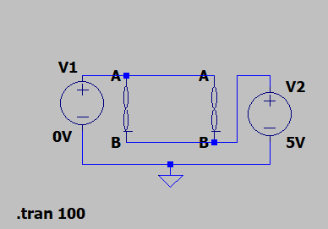

NAND NOR

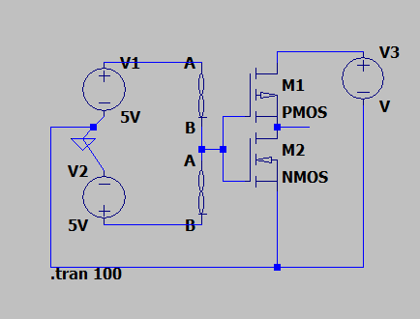 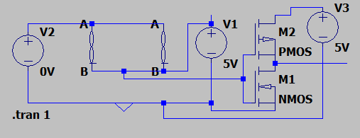

Partial Design of a 4x4 SRAM

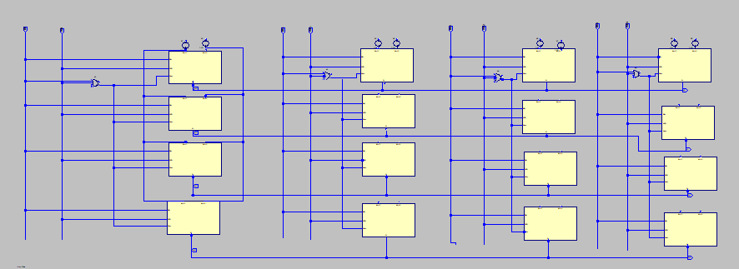

Conclusion:

This research highlights the immense potential of memristors in advancing circuit design. The successful implementation of low-pass and high-pass filters, logic gates, and memory operations using pulse signals demonstrates the versatility of memristors in both analog and digital applications. By leveraging their unique resistance-switching and memory properties, these circuits achieve compactness and efficiency. While challenges like fabrication consistency and endurance remain, this work provides a foundational step toward integrating memristor-based designs into practical systems. Future research will focus on optimizing designs and scaling for more complex applications.